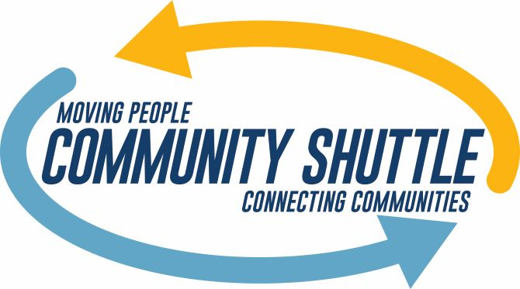
Community Shuttle Driver
At Special Mobility Services, we’re passionate about moving people because we believe that transportation lies at the heart of equity and opportunity, allowing people access to the things they need to survive and thrive. Our regional nonprofit is looking for new team members who share our passion for making a positive impact in the community.
We are hiring Drivers who will drive bus routes transporting people from rural areas such as Deer Park, Newport, Davenport and Ritzville to Spokane. We need friendly and positive individuals with an excellent driving record. This position offers approximately 15-20 hours per week with potential for additional work. Drivers will operate 14-passenger shuttle buses on flexible routes to provide safe, reliable and courteous transportation services.
We require that you have a valid driver’s license with at least two years driving experience and excellent driving record. You must be able to pass a pre-employment drug test, CDL physical, and a national criminal record check which may include fingerprint identification.
If you are interested in helping your community members, and appreciate competitive pay with excellent benefits and a supportive work environment, we encourage you to apply by submitting your resume to: hrintake@sms1.org
Special Mobility Services is an Equal Opportunity Employer
Pay: From $15.50 per hour
Benefits:
- Paid training
- Paid vacation, sick leave, and holidays
- Employer-paid retirement
COVID-19 considerations: All drivers and riders are required to wear masks and social distancing on vehicles is encouraged. Regular cleaning and sanitizing of buses is provided. Drivers are encouraged to be vaccinated against COVID-19.

